**Data Visualisation Week 2 Report assignment - Shaheer Hussain**

**NOTICE : THIS REPORT IS APPROXIMATELY 2500 WORDS, THIS EXCLUDES THE TITLES AND REFERENCE SECTION.**

**Introduction to the topic at hand :**

Over the last 50+ years the world has experienced exponential population growth due to a number of factors and we have started to consider global well-being a lot more and we've discovered factors that play into the well being score of a Country/Continent.

Population growth is the change in the number of plants or animal species in a particular location during a particular period of time **(Foflonker, 2023)** and well-being is the state of feeling happy and/or healthy. **(Cambridge Dictionary, n.d.)**

**Data source - Kaggle :**

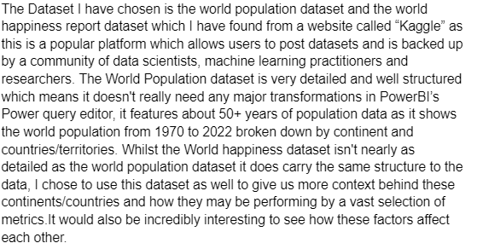

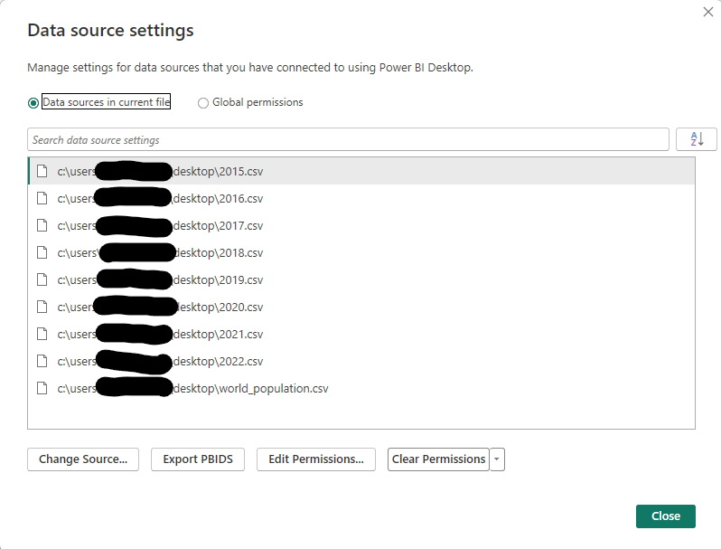

Figure 1 - Data source setting on PowerBI (Personal name used hence why part of file path is censored)

<https://www.kaggle.com/datasets/iamsouravbanerjee/world-population-dataset>

<https://www.kaggle.com/datasets/mathurinache/world-happiness-report>

**Data Transformations and cleansing :**

When it comes to data transformation, I mainly rely upon the Power query editor in Power BI, thankfully as i had mentioned earlier these two datasets were structures really well which means there wasn't much need to do any major transformations on the data, my data transformation process in this case consisted of changing data types and renaming columns so that it's more easier to read and understand what the columns actually represent. As you can see in Figure 2, there are not a lot of complex applied steps on the World happiness side of the data and there are green bars under the columns names which indicate that there isn't any missing data so the dataset is complete.  
  
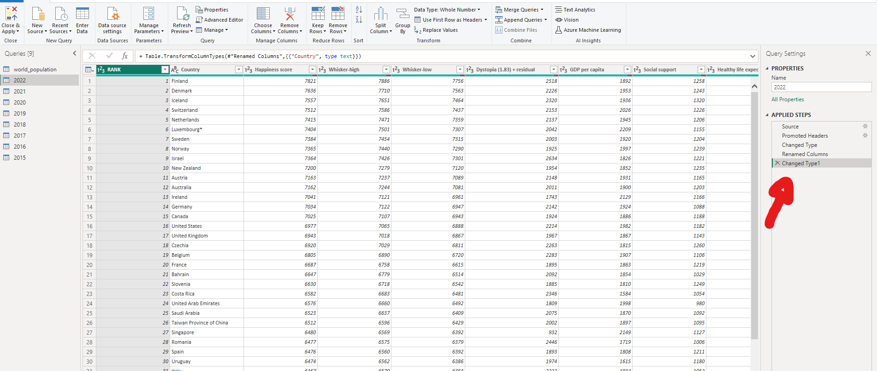

Figure 2 - Power query view, this is used to transform and cleanse the data where needed.

**Visualising the data to provide insight :**

PowerBI includes a vast selection of visualisations (As seen in Figure 3) which can be used to represent data however I chose the Map visualisation as its very simple and easy to understand, it's quite interactive, allowing the user to zoom into different areas of the map to gain a better view and it uses bubbles to represent values, i think this is an intuitive method of using maps to compare countries in terms of factors i mentioned earlier like GDP per capita, Perceptions of corruption and well-being scores.

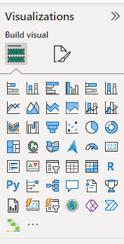

Figure 3 - Visualisations pane in PowerBI - Custom visuals can also be added to represent data in other ways.

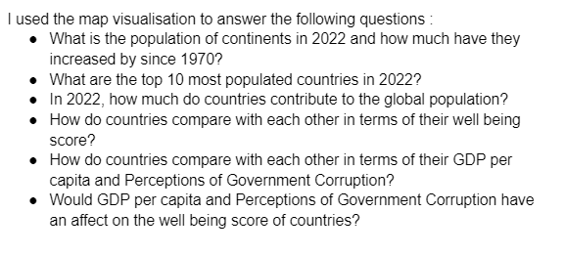

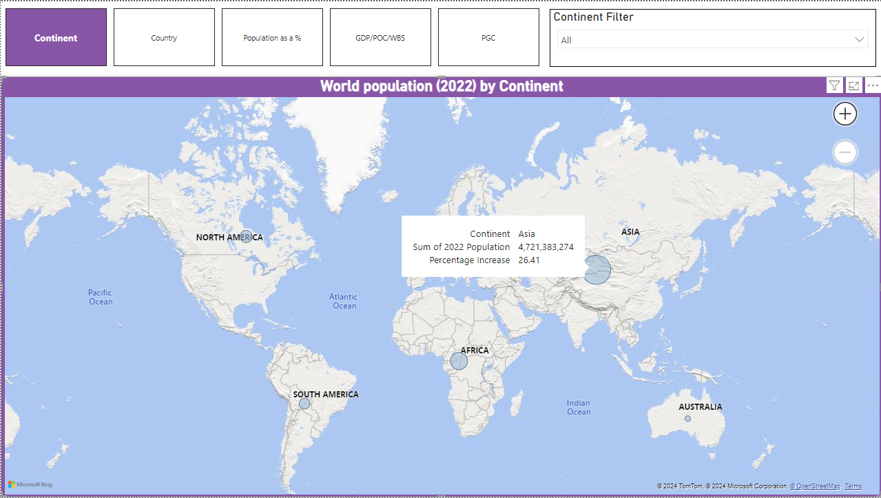

Figure 4 - World Population in 2022 by Continent, also includes the population growth from 1970 in %

In Figure 4 You can see the world's population broken down by continents However, PowerBI has a feature called “Tooltips”, this allows you to add additional information to a certain data point in a visualisation, this can be seen as I have hovered my mouse over Asia, a black card had appeared, showing the continent, 2022 population count and the population growth from 1970 to 2022. I was able to add the information showing the population growth from 1970 to 2022 by implementing 3 DAX measures shown in Figure 5, Figure 6 and Figure 7 with Figure 7 being the final measure to show this information.

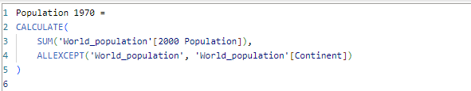

Figure 5 - DAX code used to calculate the 1970 population

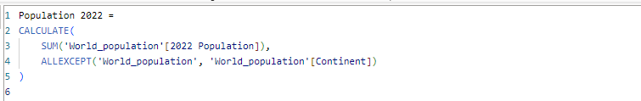

Figure 6 - DAX code used to calculate the 2022 population

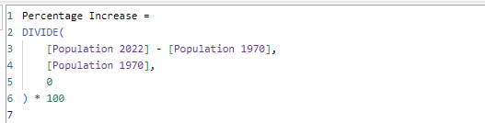

Figure 7 - DAX code used to calculate the population growth from 1970 to 2022

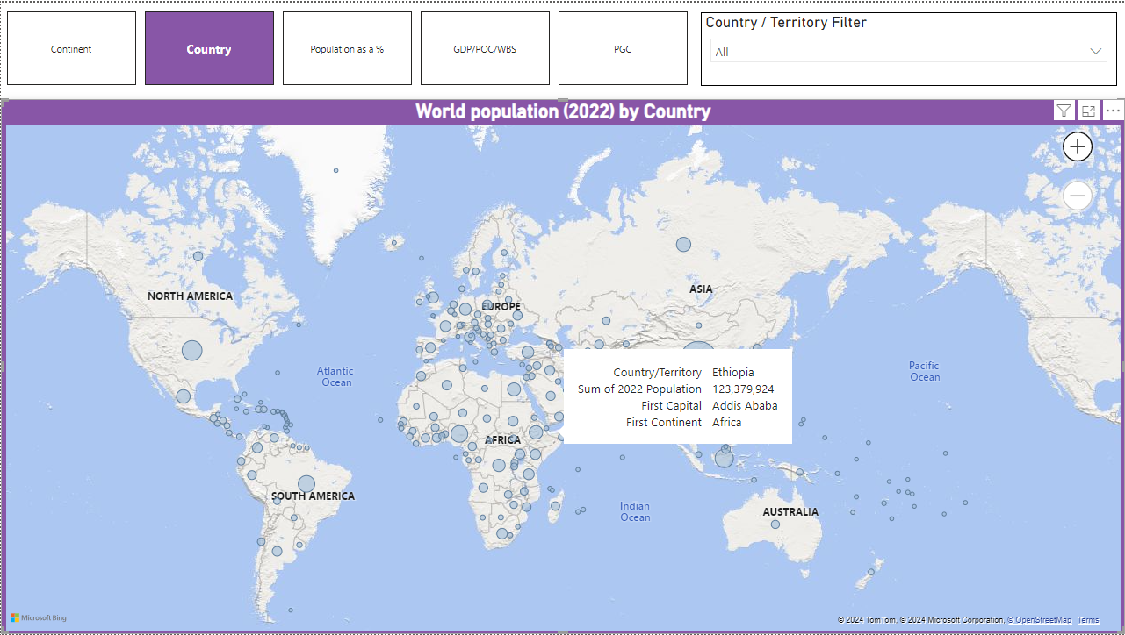

Figure 8 - World population by country - showing capital and continent in the tooltips

In Figure 8, we can see a map showing the world's population broken down by country however, here i have used the tooltips feature to show even more detail around the dataset, I have decided to show the country highlighted, the 2022 population, the capital as well as the continent the country resides in. I did not have to create any DAX measures to display this information as this information was readily available within the dataset for use.

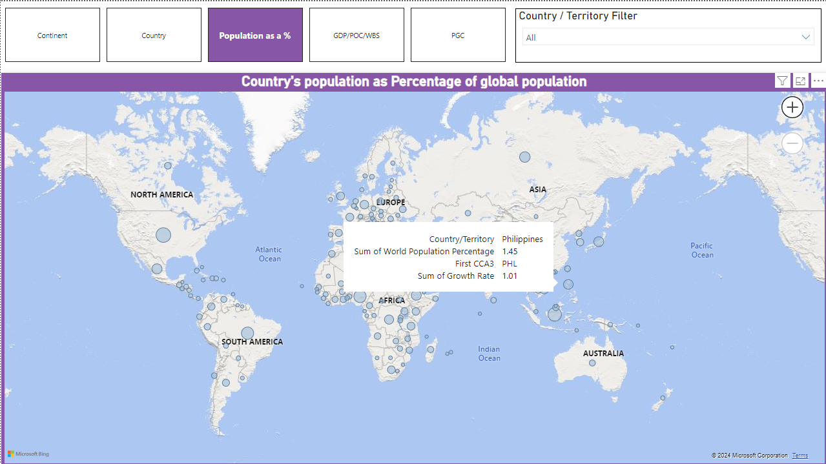

Figure 9 - Countries population as a percentage of global population - displays CCA3 code and Growth rate in tooltips

In Figure 9 you can see a map visualisation showing the countries percentage value towards global population and you can see i have included the country, percentage value, CCA3 code and growth rate of the country in the tooltip.

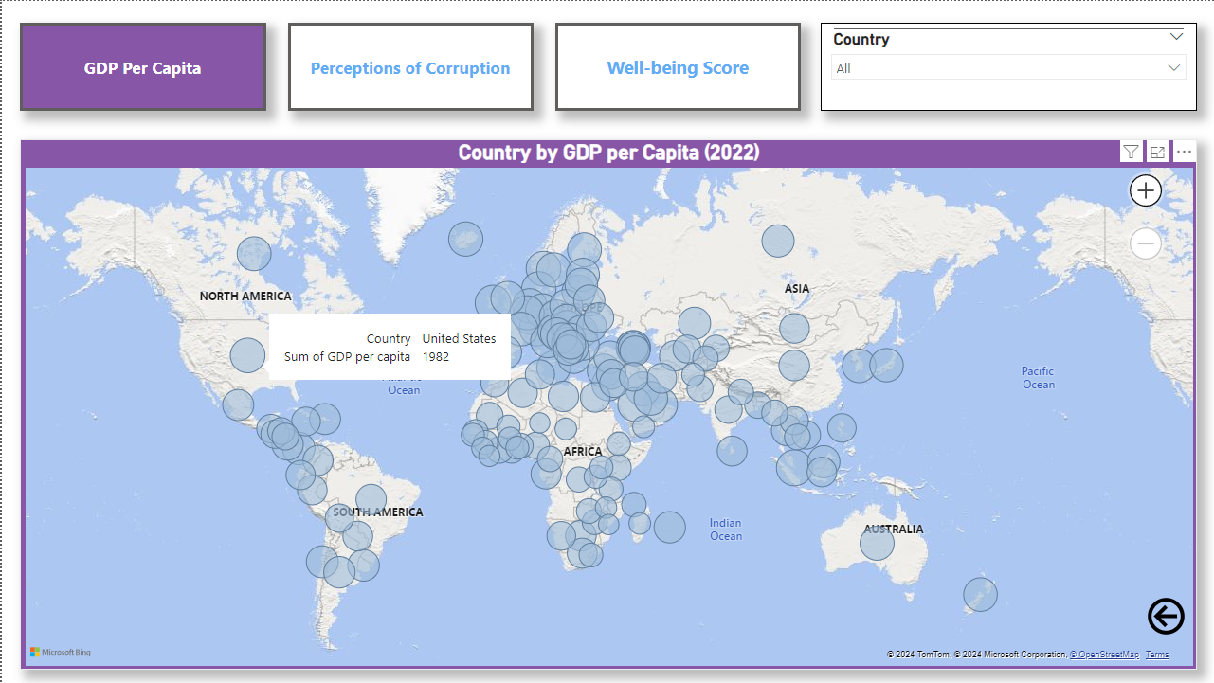

Figure 10 - Countries by their GDP per Capita - Button Selection page

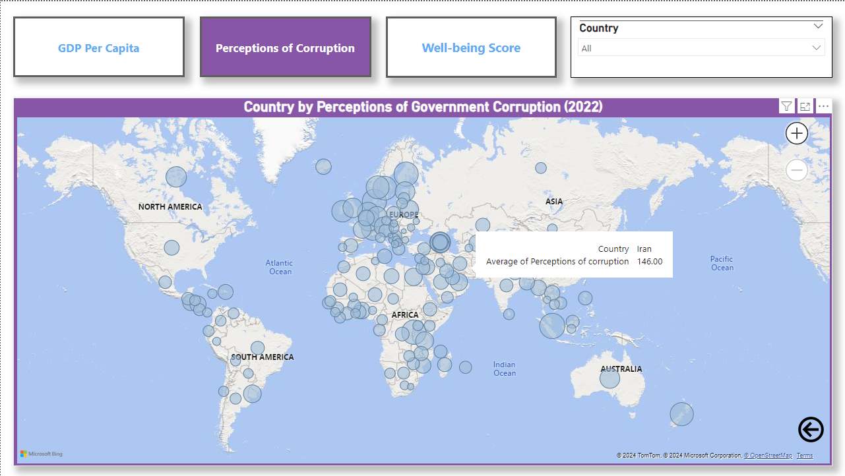

Figure 11 - Countries by their perception of government corruption - Button selection page

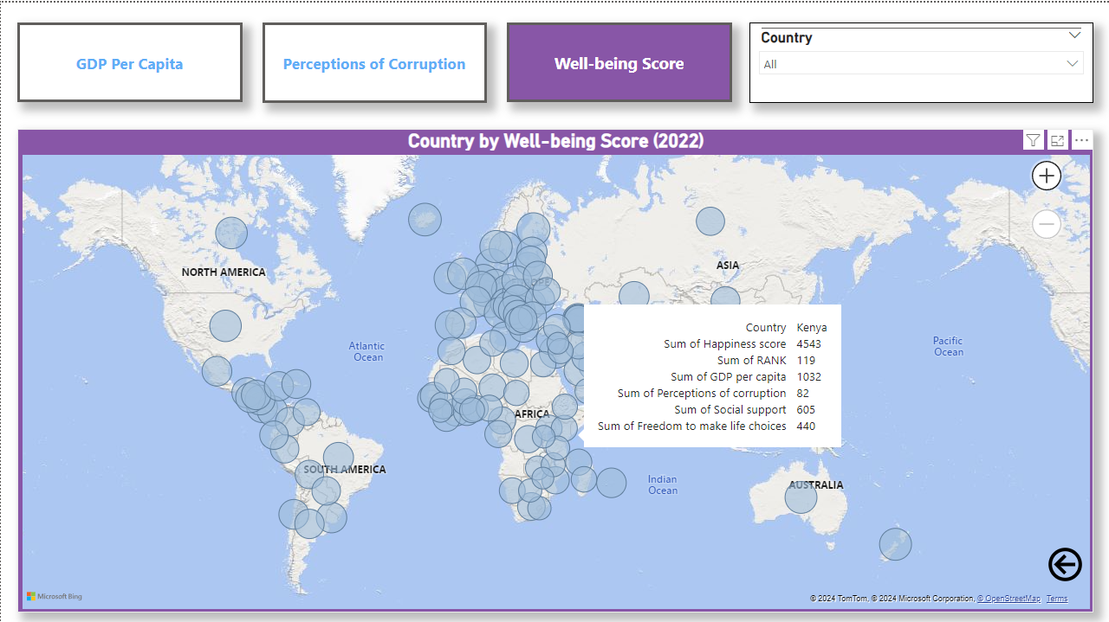

Figure 12 - Countries by their well-being score - Button selection page

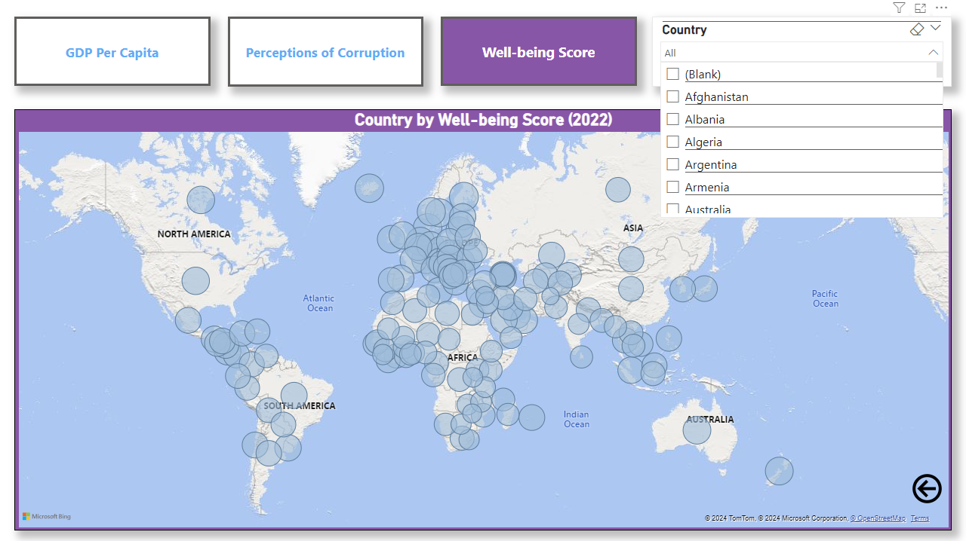

Figure 13 - Country selection slicer to filter data

In Figure 10, Figure 11 and Figure 12 you can see a page with three buttons i had created, these buttons allow you to switch between views, I created these by creating blank buttons and creating bookmarks, by creating bookmarks I am able to assign the bookmarks to the buttons as actions which make them more functional (This can be seen in Figure 14). I have also included a dropdown menu to allow the user to filter by country and this can be seen in Figure 13, the user is able to select multiple countries by holding CTRL and clicking which is how the buttons function as well. I have kept the tooltips more basic on the GDP Per Capita and Perceptions of Corruption views but I have made the Well-being view more advanced by including Happiness score, Country rank, GDP per capita, Perceptions of Government Corruption, Social support and Freedom to make life choices.

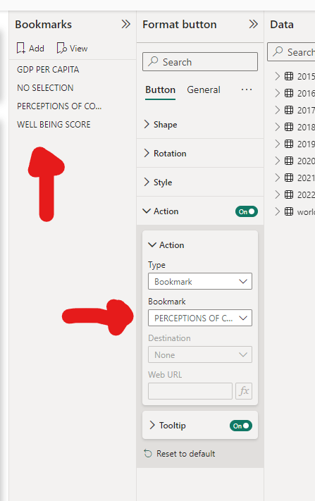

Figure 14 - Bookmark pages used to make functional buttons

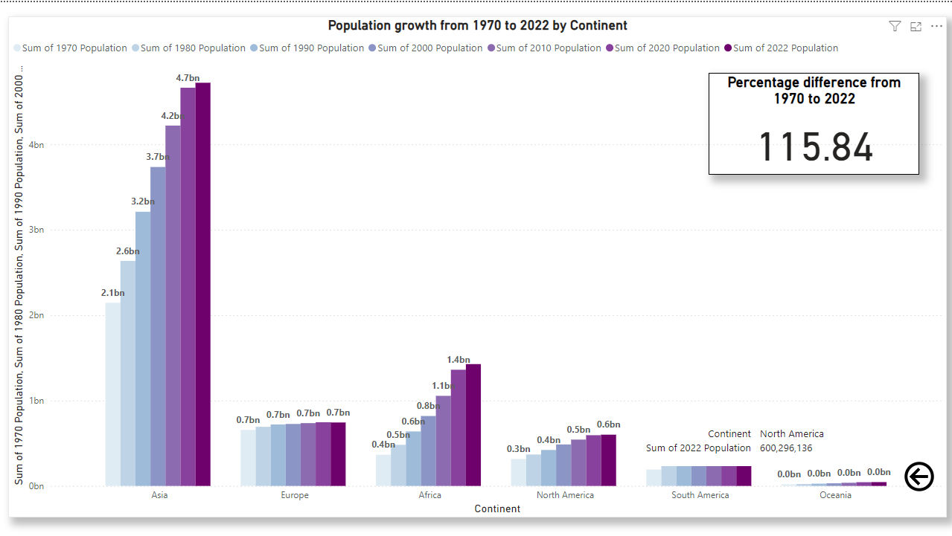

Figure 15 - Continent population growth Column chart with card visualisation

In Figure 15 you can see a column chart which shows the population growth from 1970 to 2022 and the data is broken down by continent, I understand that this project is more focussed on the use of Geolocation/Geographic visualisations but I believe that utilising other visualisations is also key in portraying a story with the data, It helps to provide insight in a way that may be more effective than just map visualisations which is the key point of data analysis and visualisation, which is to provide insights effectively.I also included a card visualisation to show the population growth from 1970 to 2022 as a percentage value.

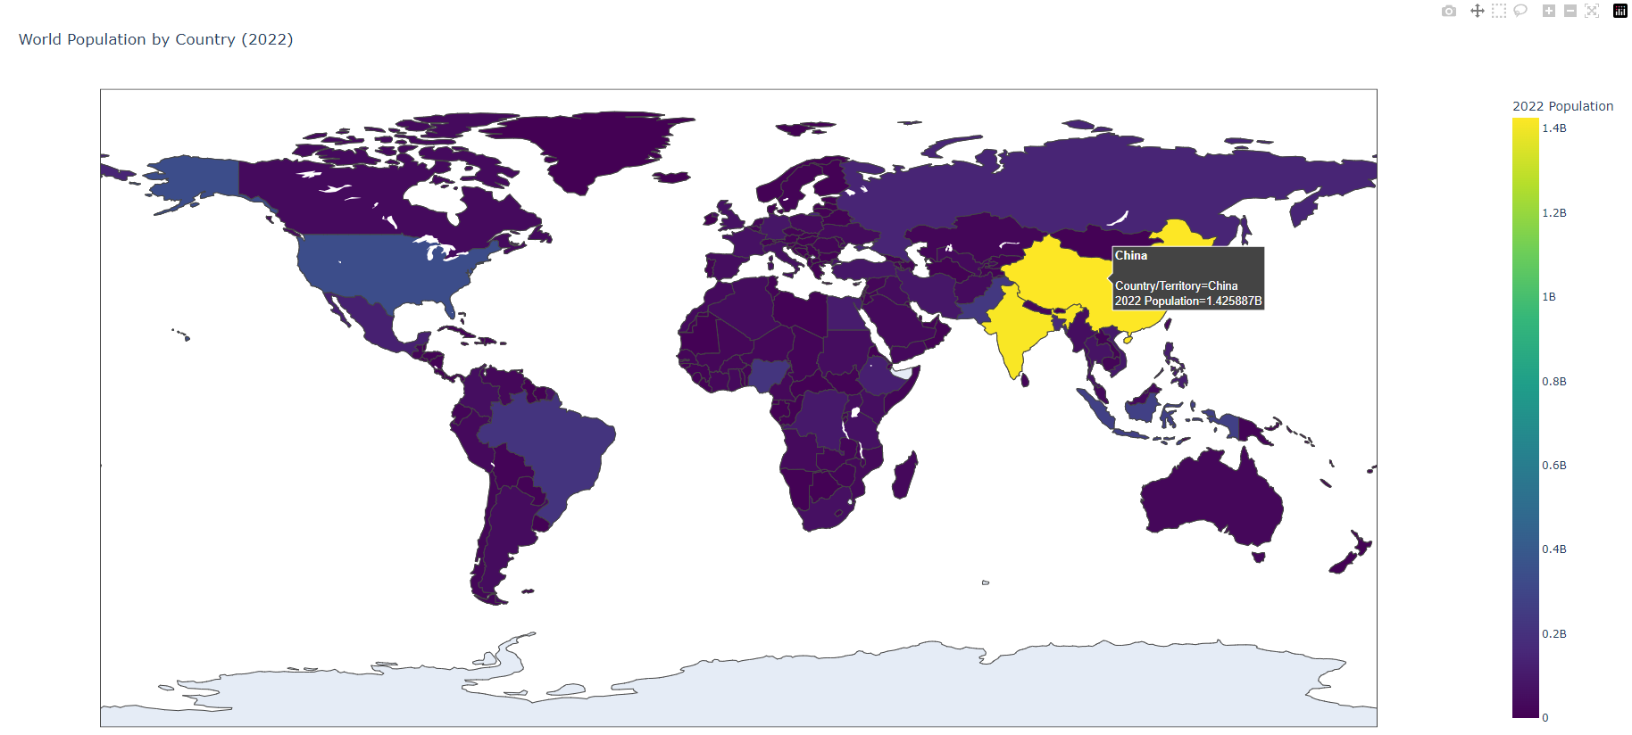

Figure 16 - Population by country but making use of a choropleth map visual using the Plotly library in Python - uses the “Virdis” colour scale which is perceptually uniform and suitable for colour blind users

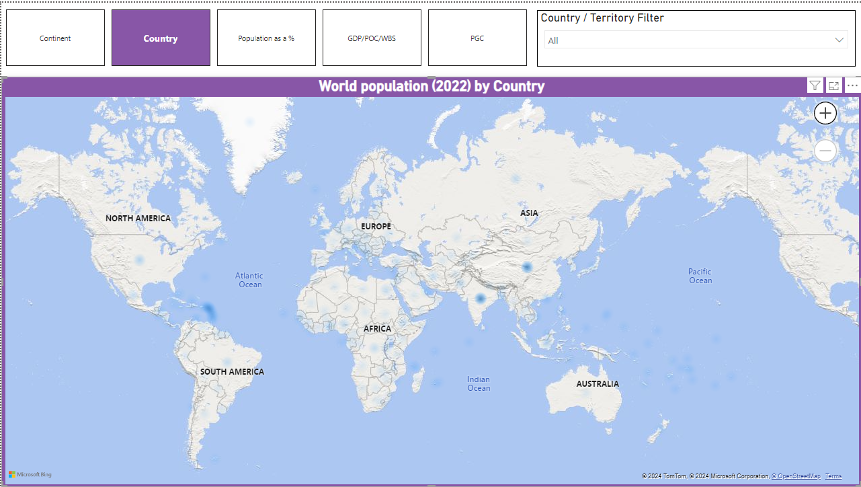

Figure 17 - Population by country as a heatmap in PowerBI - Barely visible results

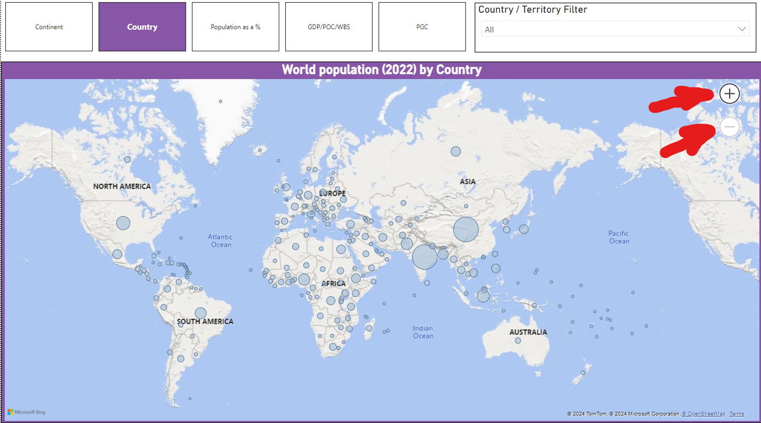

Figure 18 - Zoom feature implemented in visual highlighted

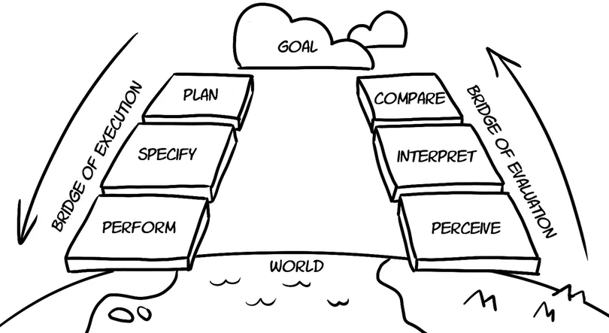

Figure 19 - Donald Norman's action lifecycle diagram

**Design principles I considered when creating my visualisations :**

When designing my visuals I have considered **simplicity and clarity** as my map visualisations use clear labels for the continents and display clear information when the user hovers over different areas of the map, making it easy to understand the geographic data and reducing cognitive load, this is only aided by the use of bubble sizes to represent proportions or colour scales (Which are colour blind supported) which i implemented in my python visuals.

I have carefully considered the **usability** of my visualisations as I have included manual zoom in and out functionality which can be seen in Figure 18, the user is also able to use their scroll wheel to zoom in and out however the manual buttons are there in case the user does not have a mouse to scroll on. I have included custom buttons for navigation in Figure 10, Figure 11 and Figure 12. These buttons allow the user to easily navigate through each page without having to think about anything, whilst this isn't an insightful visual I believe it contributes towards a more interactive design which follows Ben shneiderman's 7th golden rule which is to keep users in control and make them aware that they are in control.**(GeeksforGeeks, 2023)** This also demonstrates my implementation of Ben’s with rule which is to reduce Short term memory load as humans have limited capacity for information processing **(GeeksforGeeks, 2023)** so having the navigation and zooming buttons right in front of the users allow them to use manipulate the visuals without having to think about it much, this is good design practice, This also covers my implementation of the **Interactivity** design principles as users can directly interact with the visuals and even click bubbles to filter the data itself.

Both my PowerBI and Python visuals are extremely **responsive** in design, with PowerBI, there is milliseconds of loading time when users are navigating the pages, filtering data by clicking the bubbles and there's even less delay when zooming in and out, contributing towards a responsive design that reinforces the user feeling of control and speeds up the rate of users learning how to navigate the visuals i've built. This goes for the tooltips as well since these small cards of information pop up instantly when a user hovers over a country and this ties in quite nicely to my python visualisation since its tooltips are also very responsive.

Norman's action lifecycle is an important concept in design and it is a model for the way that humans interact with any sort of object whether it is in the real world or on a screen and this can be seen in Figure 19.The seven stages of this life cycle is divided into the “Bridge of execution” (Where people plan, specify and perform) and the “Bridge of evaluation” (Where people perceive, interpret and compare) **(Programmers, 2023)**

As mentioned earlier I have already taken accessibility into account with my visual’s designs as I have included zoom features so that users can see the visual more clearly but more importantly, I have used a colour set which is colour blind supported and this can be seen in Figure 16 where I have made use of the “Virdis” colour scale which is perceptually uniform and suitable for colour blind users.This can also be seen in the colour scheme for my PowerBI visualisations.

**Application of Norman's Action Cycle to Your Visualisation:**

**Goal Formation:**

* Users aim to understand world population distribution by country.

**Execution:**

* Users interact with the map, using filters to customise their view based on specific criteria such as continent, country, and other demographic factors.
* Users perceive the distribution through bubble sizes and locations.

**Evaluation**:

* Users interpret the sizes and locations of bubbles to draw conclusions about population distribution.
* Users compare the visualised data with their initial goal (e.g., finding the most populous countries or understanding regional population densities).
* By considering Norman's Action Cycle, your visualisation can be designed to better support users in each stage of their interaction. Enhancements such as improved interactivity and clearer annotations can facilitate smoother execution and more accurate evaluation of their goals.

**Insights gained from the visualisations :**

* What is the population of continents in 2022 and how much have they increased by since 1970?

Asia 2022 Population - 4,721,282,274 - 290.41% Population increase from 1970

Africa 2022 Population - 1,426,730,932 - 120.12% Population increase from 1970

Australia 2022 Population - 45,038,554 - 131.20% Population increase from 1970

Antarctica 2022 Population - 0 - 0% Population increase from 1970

Europe 2022 Population - 743,147,538 - 13.31% Population increase from 1970

South America 2022 Population - 436,816,608 - 126.39% Population increase from 1970

North America 2022 Population - 600,296,136 - 90.31% Population increase from 1970

* What are the top 10 most populated countries in 2022?

1. China - 1,425,887,337
2. India - 1,417,173,173
3. United states - 338,289,857
4. Indonesia - 275,501,339
5. Pakistan - 235,824,862
6. Nigeria - 218,541,212
7. Brazil - 215,313,498
8. Bangladesh - 171,186,372
9. Russia - 144,713,314
10. Mexico - 127,504,125

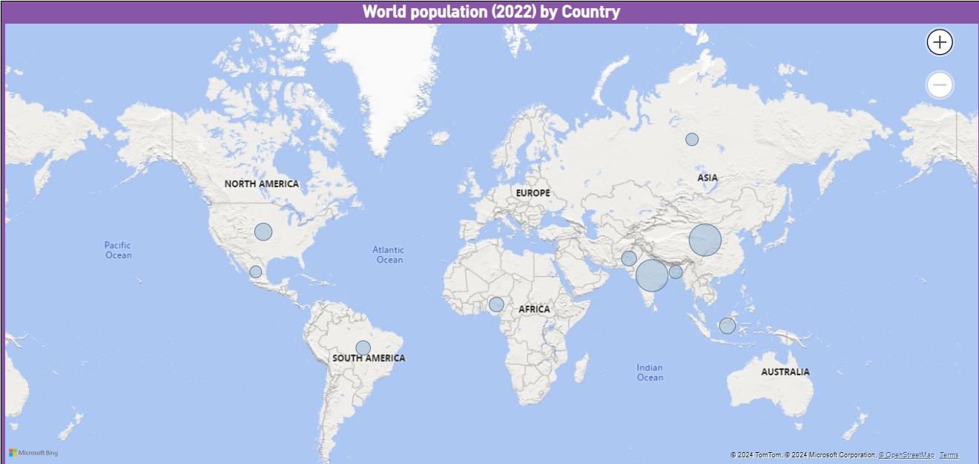

* In 2022, how much do countries contribute to the global population?

China - 17.88% of global population

India - 17.77% of global population

United states - 4.24% of global population

Indonesia - 3.45% of global population

Pakistan - 2.96% of global population

Nigeria - 2.74% of global population

Brazil - 2.70% of global population

Bangladesh - 2.15% of global population

Russia - 1.81% of global population

Mexico - 1.60% of global population

* How do countries compare with each other in terms of their well being score?

If we take the top 10 most populated countries we can see that the United States has the highest wellbeing score **(Score of 6977)** with Brazil being a close second **(Score of 6293)**, I suspect this is due to either high GDP per capita or level of social support as these are prominent figures. On the other hand, India and Pakistan **(Score of 4516)** have the lowest well being score with India being the worst **(Score of 3777)**.I suspect this is due to the lower level of social support and GDP per capita although social support has taken the bigger hit according to my visualisation.

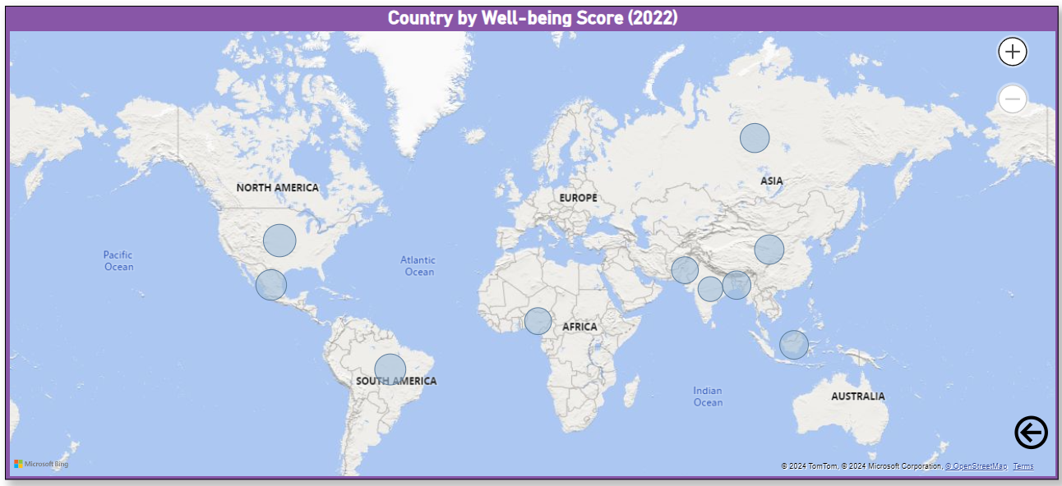

* How do countries compare with each other in terms of their GDP per capita and Perceptions of Government Corruption?

If we take the top 10 most populated countries, my visualisation describes Nigeria **(Score of 38)** and Indonesia **(Score of 47)** to be the countries with the lowest perception of government corruption with Bangladesh having the most perception of government corruption **(Score of 187)**.In terms of GDP per capita, the United States is in lead with a score of **1982** and Pakistan is at the bottom with a score of **1049**

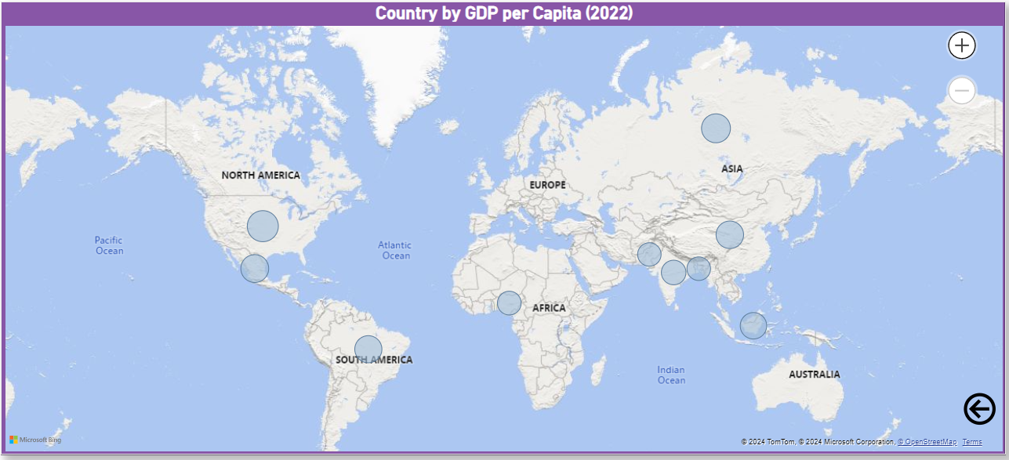

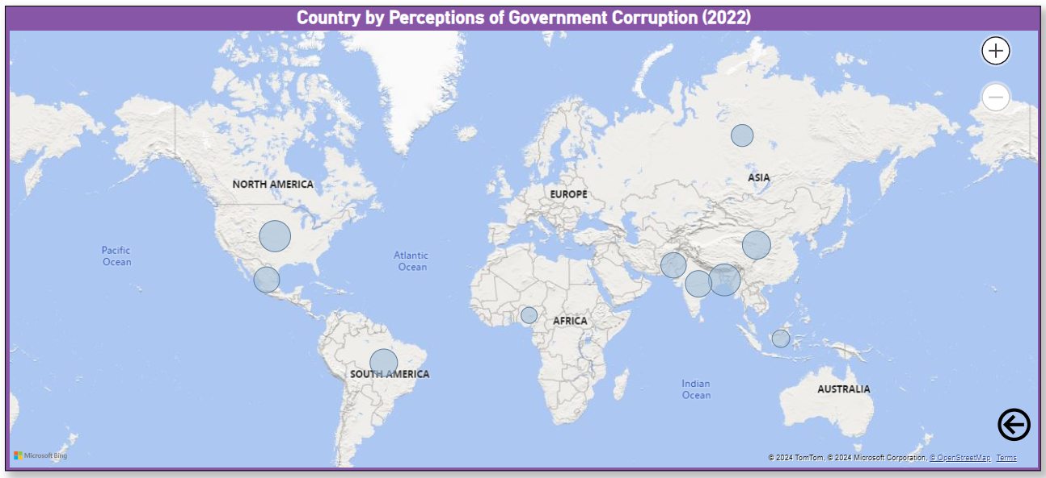

* Would GDP per capita and Perceptions of Government Corruption have an affect on the well being score of countries?

Perceptions of government corruption and GDP per capita do significantly affect the well being scores of countries as a higher GDP per capita generally correlates with better well being due to increased access to services and resources, However, higher perceptions of government corruption often do correlate with lower well being scores as they erode the public trust in institutions and reduce the effectiveness of public services.**(worldhappiness.report, n.d.) (Transparency International, 2020) (www.oecd.org, n.d.)**

**Conclusions :**

When looking at population data visually, choropleth maps are a choice because they can effectively show population densities across various regions. Choropleth maps shade or colour areas, like countries, states or cities based on their population size or density. This type of map lets you quickly see which regions have low population densities. Darker shades mean populations while lighter shades indicate lower populations. Choropleth maps are helpful for giving an idea of how populations are spread out, helping decision makers and researchers understand where people live in large numbers and where they're more sparse. This information can be valuable for planning infrastructure, allocating resources and developing areas.

Dot density maps are another way to visualise population data especially when you want to show how populations are distributed within regions or cities. In dot density maps each dot represents a number of people. Is placed in the corresponding geographic area. This approach provides a view of population distribution compared to choropleth maps because it can reveal clustering and dispersion within areas. For example in a city map with dot density representation you might see clusters of dots in downtown areas indicating population concentrations while there may be fewer dots in suburban or rural zones. Dot density maps prove useful, for city planners and health officials seeking insights into population distributions for services like transportation, healthcare and emergency response planning.

Similarly heat maps offer a way to visualise population data especially when delving into the intensity of population concentrations in a gradient like manner. By using colours to depict population densities – with warmer hues like red or orange indicating densities and cooler shades like blue or green representing densities – heat maps allow for the identification of subtle patterns in population density that may not be as easily discernible on other types of maps. Essentially they can uncover hotspots of population activity and trends over time thus aiding in analyses such as migration studies or monitoring growth. Decision makers and analysts can leverage these visualisations to tackle issues related to high density areas, including overcrowding, traffic congestion and environmental impacts.

**References :**

**Foflonker, F. (2023). *Population growth | biology*. [online] Encyclopedia Britannica. Available at:** [**https://www.britannica.com/science/population-growth**](https://www.britannica.com/science/population-growth)**.**

**‌Cambridge Dictionary (n.d.). *WELL-BEING | Meaning in the Cambridge English Dictionary*. [online] Cambridge.org. Available at:** [**https://dictionary.cambridge.org/dictionary/english/well-being**](https://dictionary.cambridge.org/dictionary/english/well-being)**.**

**GeeksforGeeks. (2023). *Ben Shneiderman eight golden rules of interface design (Human Computer Interaction)*. [online] Available at:** [**https://www.geeksforgeeks.org/ben-shneiderman-eight-golden-rules-of-interface-design-human-computer-interaction/**](https://www.geeksforgeeks.org/ben-shneiderman-eight-golden-rules-of-interface-design-human-computer-interaction/)**.**

**‌Programmers, T.P. (2023). *Understanding Norman’s Action Lifecycle*. [online] The Pragmatic Programmers. Available at:** [**https://medium.com/pragmatic-programmers/understanding-normans-action-lifecycle-179e6c46368**](https://medium.com/pragmatic-programmers/understanding-normans-action-lifecycle-179e6c46368)**.**

**CEPF®, T.T., BSc (2024). *GDP Per Capita | Definition | Finance Strategists*. [online] Finance Strategist. Available at:** [**https://www.financestrategists.com/wealth-management/macroeconomics/gdp-per-capita/**](https://www.financestrategists.com/wealth-management/macroeconomics/gdp-per-capita/)**.**

**‌worldhappiness.report. (n.d.). *Read the Reports*. [online] Available at:** [**https://worldhappiness.report/archive/**](https://worldhappiness.report/archive/)**.**

**Transparency International (2020). *Corruption Perceptions Index 2020* . [online] Transparency International. Available at:** [**https://www.transparency.org/en/cpi/2020/index/nzl**](https://www.transparency.org/en/cpi/2020/index/nzl)**.**

**‌www.oecd.org. (n.d.). *How’s Life? 2020: Measuring Well-being | en | OECD*. [online] Available at:** [**https://www.oecd.org/statistics/how-s-life-23089679.htm**](https://www.oecd.org/statistics/how-s-life-23089679.htm)**.**

**‌**

**‌**

**‌**

**‌**

**‌**

**‌**

**‌**

**‌**